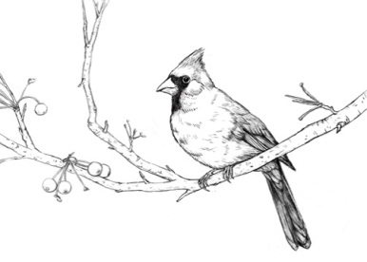
Syllabus: Environmental Science

Materials:
1.5’’-2’’ 3 ring binder, loose paper, pens, pencils, folder, copy paper
Journal-composition book or spiral notebook

Overview:
Environmental Science is the interaction and impact of living and non-living factors in the environment

Course Outline:

- Intro to Environmental
- Energy Sources
- Pollution & Population
- Intro to Ecology
- Ecological Sustainability
- Green Revolution

Grading:
Category | Percent of Grade
Classwork/Writing | 25%
Quizzes | 10%
Labs/Projects | 30%
Unit Tests | 20%
Final Exam | 15%
All Cobb County Schools use the following grading scale:
A = 90 -100% B = 80 - 89% C = 74 -79% D = 70 -73% F = 0 - 69%

Class work & Writing will include a variety of graded exercises done in class. (Class work may be assigned as homework if more time is needed to complete the assignment as determined by the teacher.)

Exams (including final), projects and quizzes will be used to determine knowledge of key terminology and concepts from each unit and will vary in length depending on the given subject matter. These exams will employ a variety of questions types, including but not limited to: multiple choice, fill in the blank and free response (essay).

Labs will be used to determine ability to measure physical events and interpret them with respect to course concepts.

Projects will be graded by a rubric that will be provided at the time the assignment is given. These assignments will require student research and presentation of findings to the class.

Late Work & Missing Work: All unit work must be turned in by the date of the unit exam. Work submitted after the exam date will not be accepted without a parent-teacher conference.

Cheating will result in a zero with no opportunity for retakes. Cheating includes but is not limited to plagiarism, copying another student’s work, putting your name on another student’s work, using electronic assistance without teacher permission, obtaining any other unauthorized assistance to complete any assignment.

Class Expectations:
- Proper safety procedures MUST be followed at all times when in the lab/classroom

Highway to Success

Preparation | Communication | Participation | Concentration
-Be on time  -Bring your materials  -Stay organized  -Get in science mode  -Do homework/study  -Get enough sleep | -Confused or lost?.... Ask questions  -Be respectful in your actions and speech  - Need something like...  -Want to eat?  -Charge phone?  - Go to restroom?  JUST ASK! | -Make an effort, NOT an excuse!  -Follow directions  -Raise your hand  -Stay engaged during class | -Stay focused by...  Keeping ALL electronics  OFF and put away!  *unless instructed otherwise by Mrs. Almeda*

By signing below, I have read and understand all parts of this syllabus. If at any time I am concerned or have any questions, I can and will contact my teacher.

Student signature: _________________________________ Date:___________

Parent/Guardian signature: __________________________ Date:___________

